**Early Sensing of the Four Horsemen Worksheet**

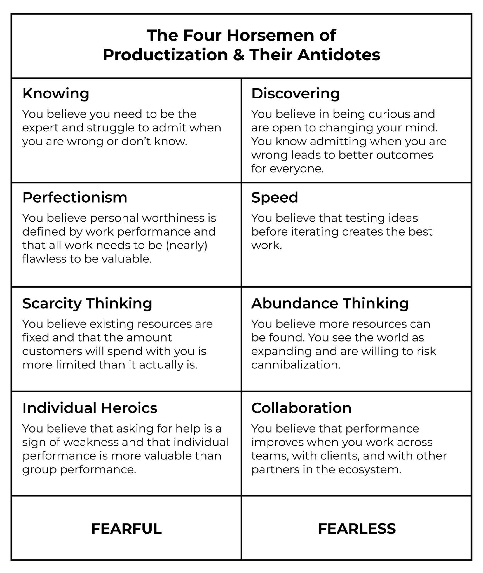

***Knowing ➡️ Discovering***

1. How does this present in our organization today?
2. Who needs to help to change ‘Knowing’ behaviors?
3. How can we operate in ways to support ‘Discovering’ behaviors?
4. Who would be able to identify if ‘Knowing’ behaviors are coming back?
5. What incentives need to be aligned with ‘Discovering’ behaviors?

***Perfectionism ➡️ Speed***

1. How does this present in our organization today?
2. Who needs to help to change ‘Perfectionism’ behaviors?
3. How can we operate in ways to support ‘Speed’ behaviors?
4. Who would be able to identify if ‘Perfectionism’ behaviors are coming back?
5. What incentives need to be aligned with ‘Speed’ behaviors?

***Scarcity Thinking ➡️ Abundance Thinking***

1. How does this present in our organization today?
2. Who needs to help to change ‘Scarcity Thinking’ behaviors?
3. How can we operate in ways to support ‘Abundance Thinking’ behaviors?
4. Who would be able to identify if ‘Scarcity Thinking’ behaviors are coming back?
5. What incentives need to be aligned with ‘Abundance Thinking’ behaviors?

***Individual Heroics ➡️ Collaboration***

1. How does this present in our organization today?
2. Who needs to help to change ‘Individual Heroics’ behaviors?
3. How can we operate in ways to support ‘Collaboration’ behaviors?
4. Who would be able to identify if ‘Individual Heroics’ behaviors are coming back?
5. What incentives need to be aligned with ‘Collaboration’ behaviors?